

Estimated time needed: **30** minutes

Objective for Exercise:

* For this project, you will use your IBM Watson Studio account from the previous chapter.

*If you have not created a Watson service before proceed with Step 1, otherwise go to Step 2:*

Step 1: For New Users (with no Watson service):

Go to the IBM Cloud Watson Studio page:

[Click here](https://cloud.ibm.com/catalog/services/watson-studio?cm_mmc=Email_Newsletter-_-Developer_Ed%2BTech-_-WW_WW-_-SkillsNetwork-Courses-IBMDeveloperSkillsNetwork-PY0101EN-SkillsNetwork-19487395&cm_mmca1=000026UJ&cm_mmca2=10006555&cm_mmca3=M12345678&cvosrc=email.Newsletter.M12345678&cvo_campaign=000026UJ" \t "_blank)

You will see the screen in the figure below. Click the option in the red box.

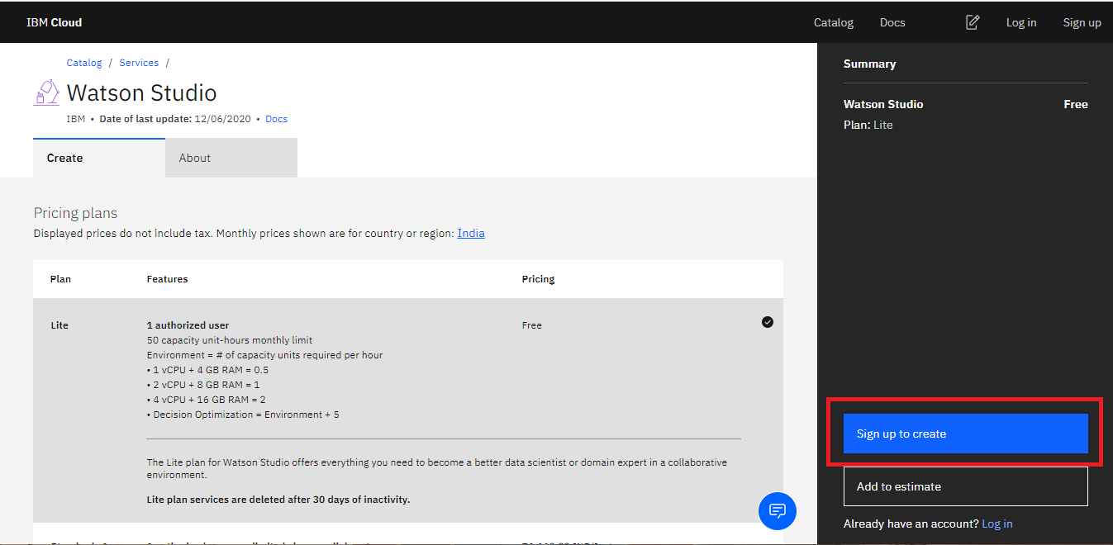

You will see the screen in the figure below. Enter **Email** and **Password** and the click **Next**.

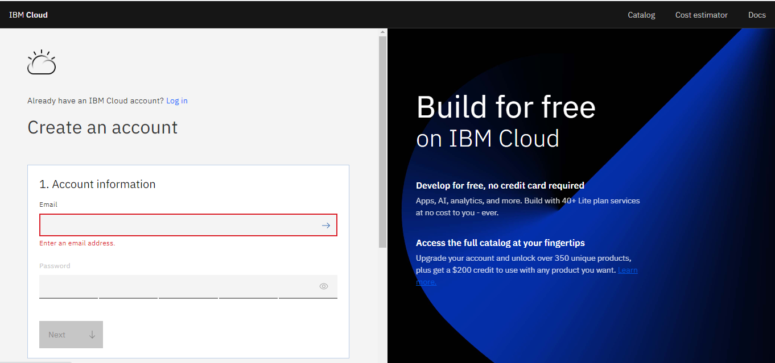

Enter the verification code to verify email and click **Next**.

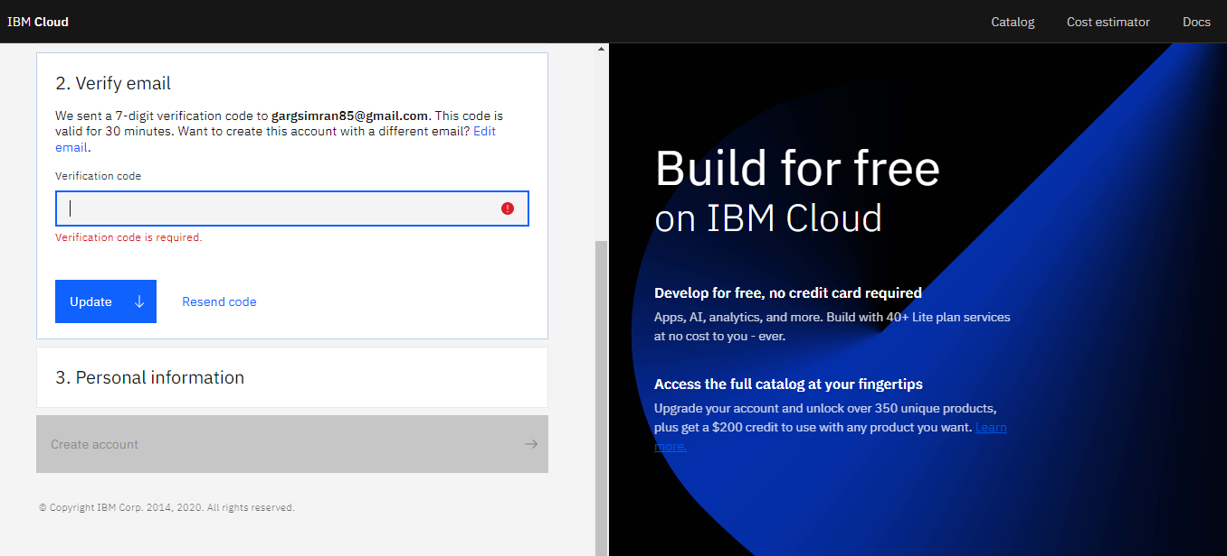

Enter your personal information and click **Next**.

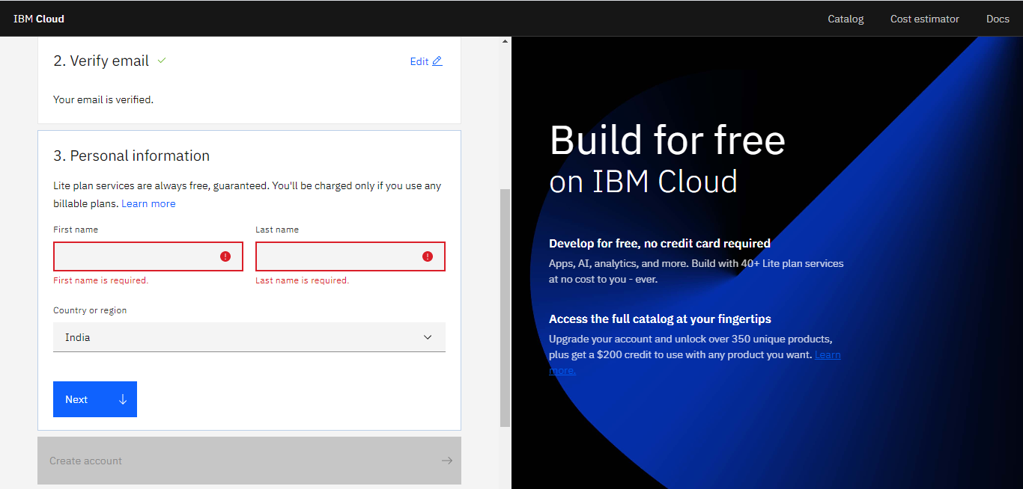

Accept the terms and conditions and click on **Create account**.

You will see the screen in the figure below. Click on the **Create** button.

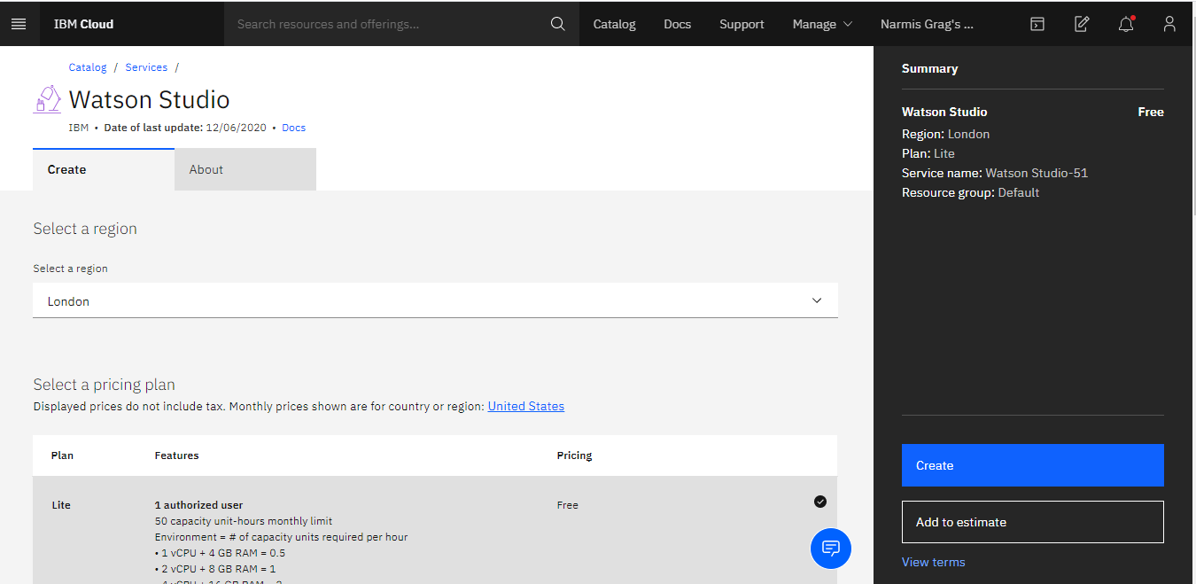

Now click **Get Started**.

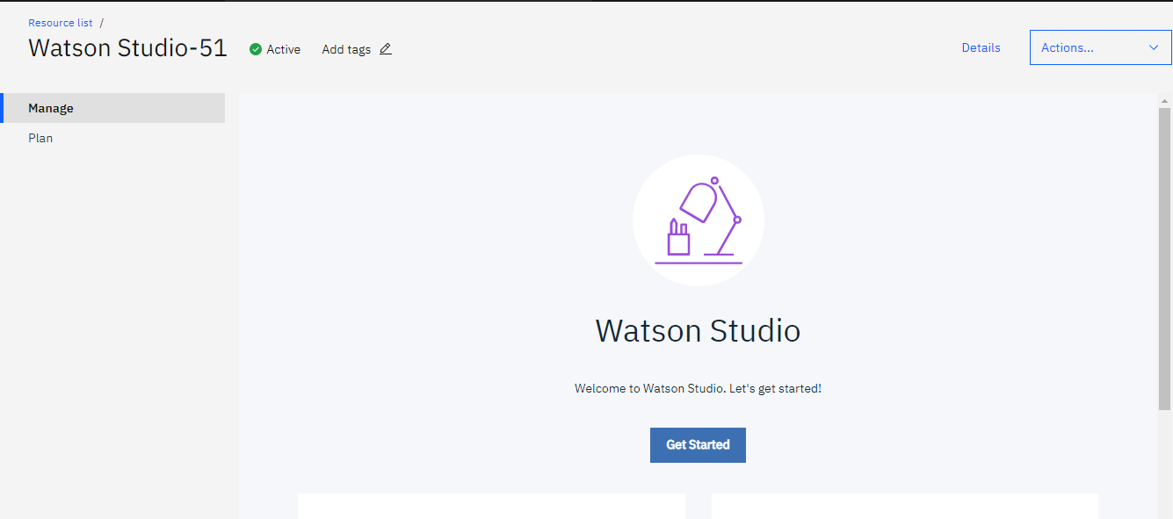

Then click **Go to IBM Watson Studio**.

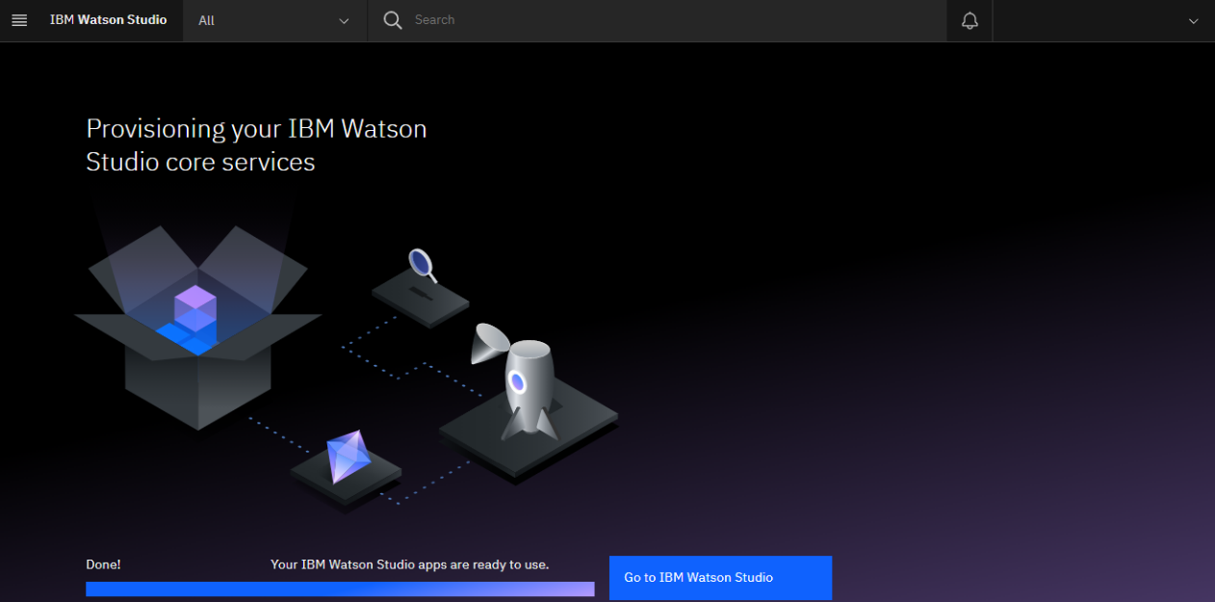

Then click **Continue**.

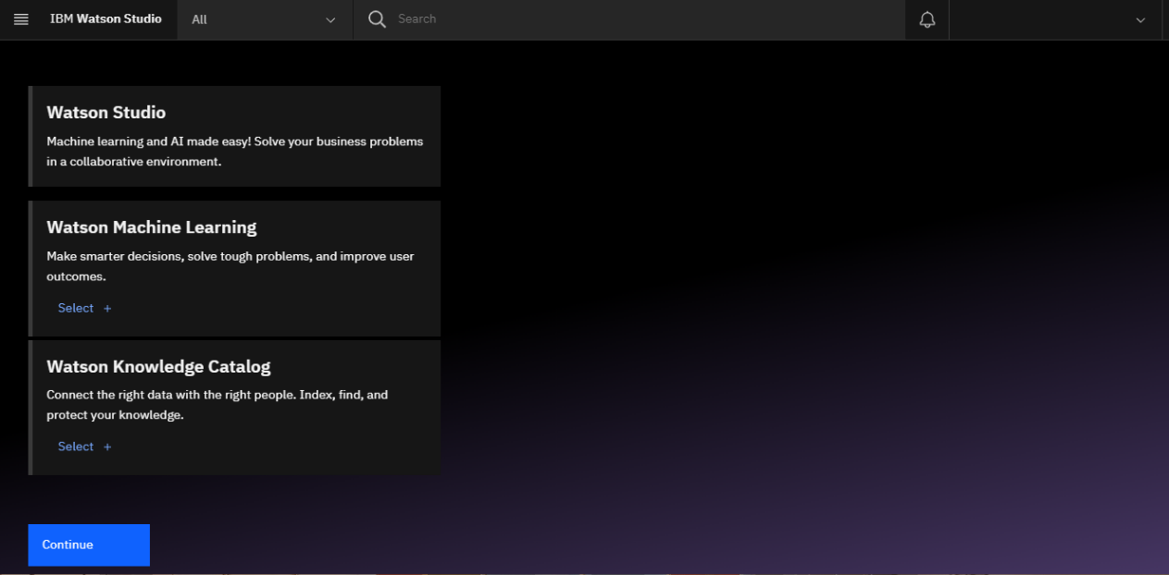

After creating the service continue with Step 2.

Step 2: For Existing Users (who already have Watson Service):

Go to the IBM Cloud Dashboard and click **Services**.

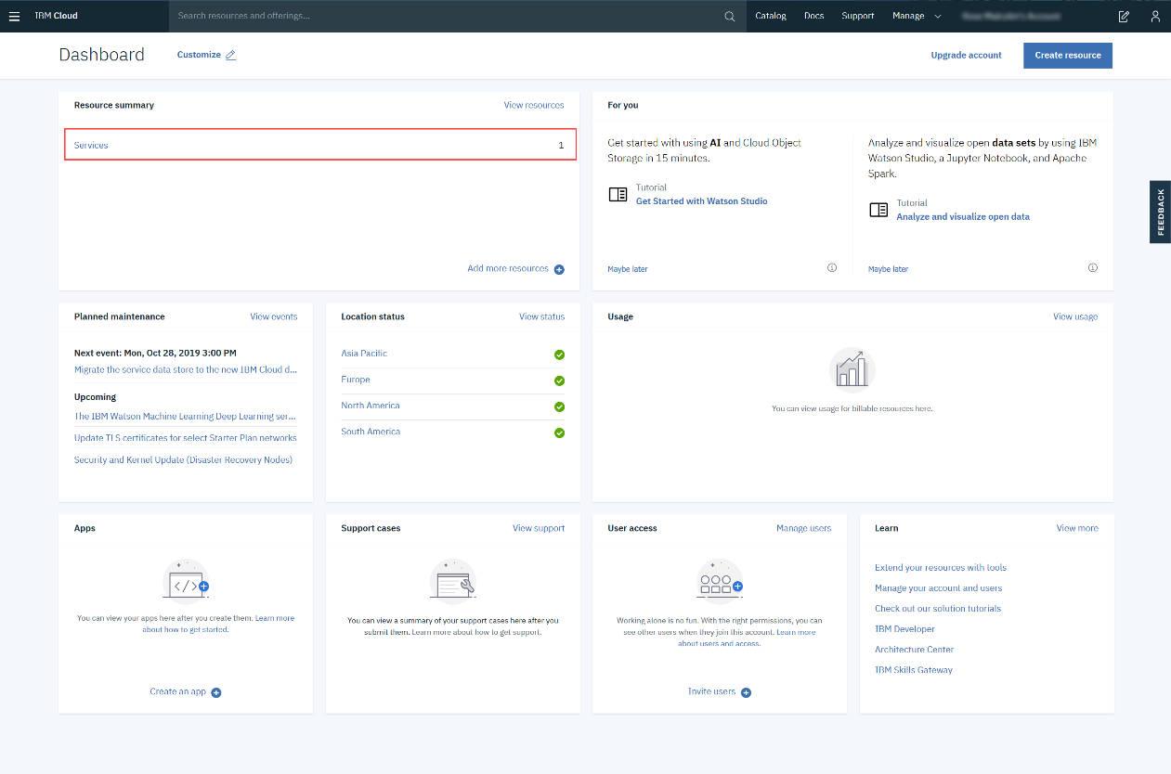

When you click on Services, all your existing services will be shown in the list. Click the **Watson Studio** service you created.

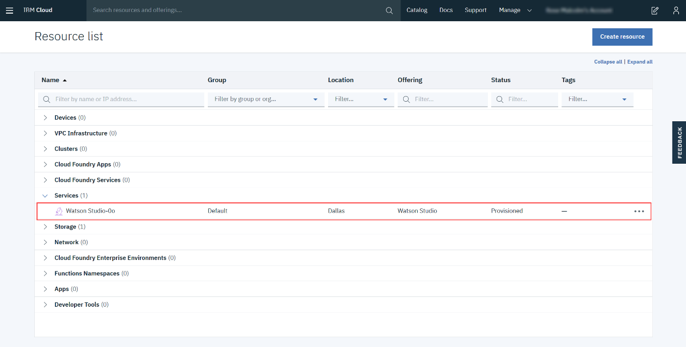

Then click **Get Started**.



Step 3: Creating a Project

Now you have to Create a project.

Click on **Create a project**.

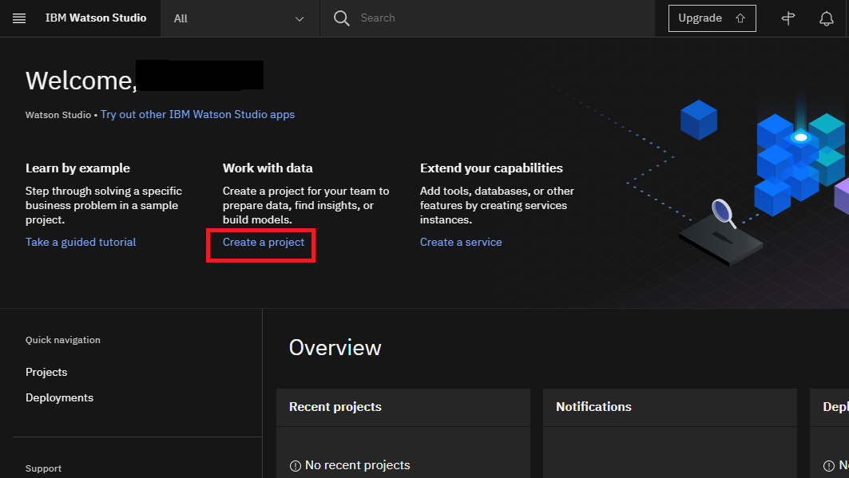

On the Create a project page, click **Create an empty project**.

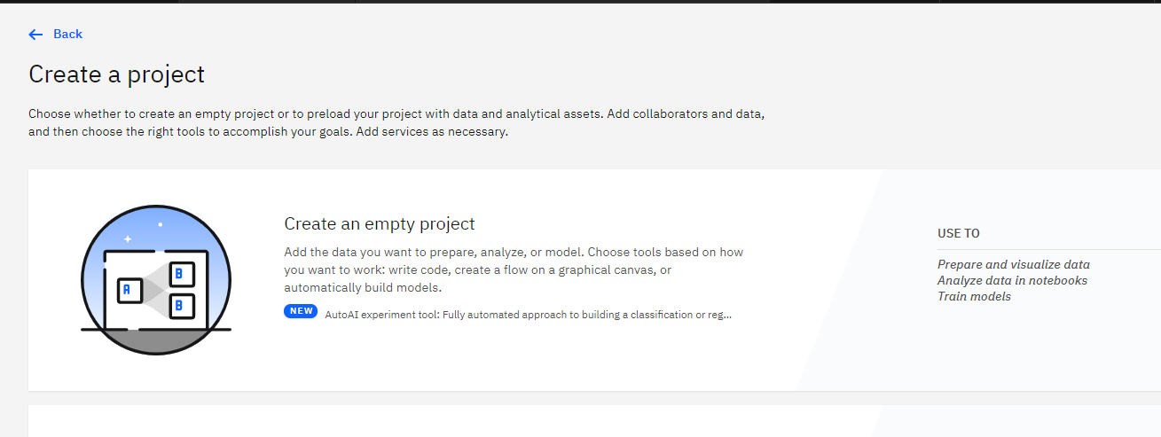

Provide a **Project Name** and **Description**.

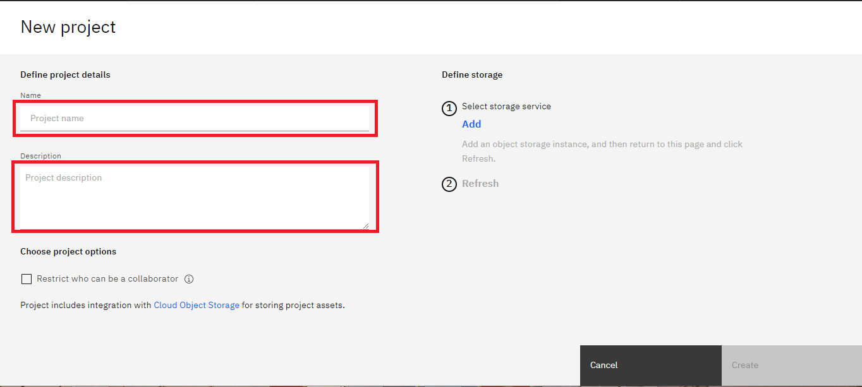

You must also create storage for the project.

Click **Add**

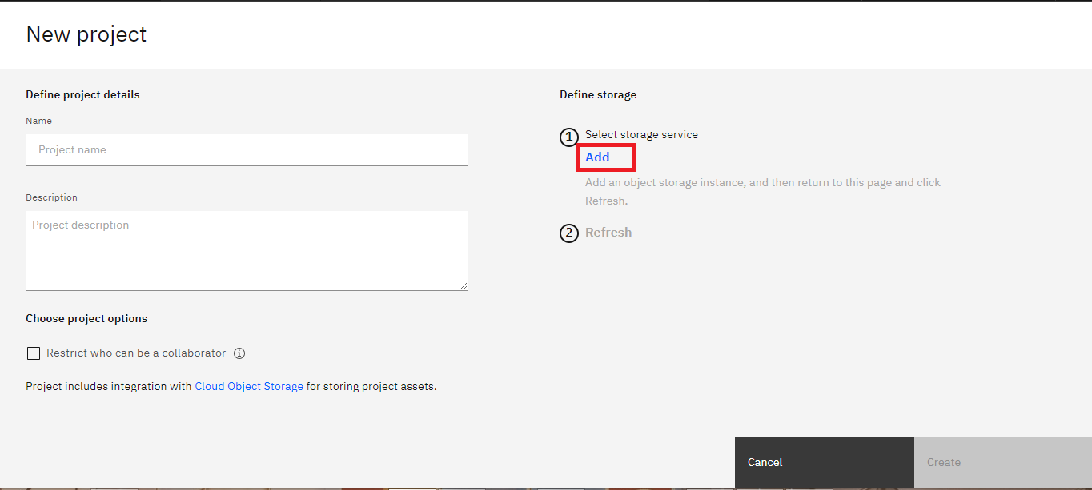

On the Cloud Object Storage page, click **Create**.

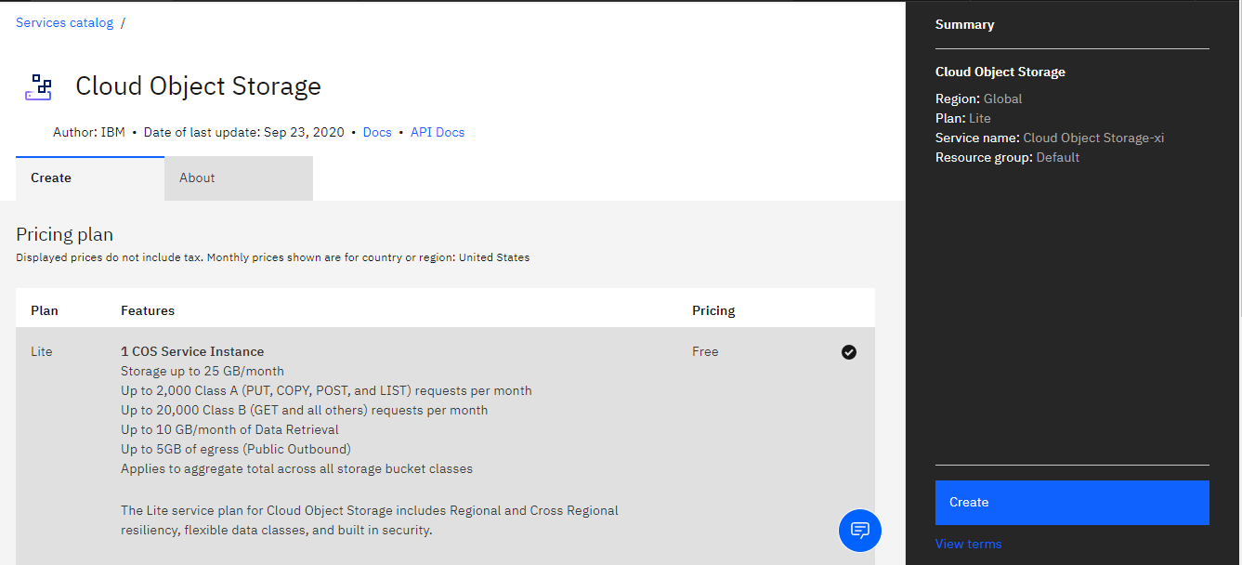

On the New project page, note that the storage has been added, click **Refresh** and then click **Create**.

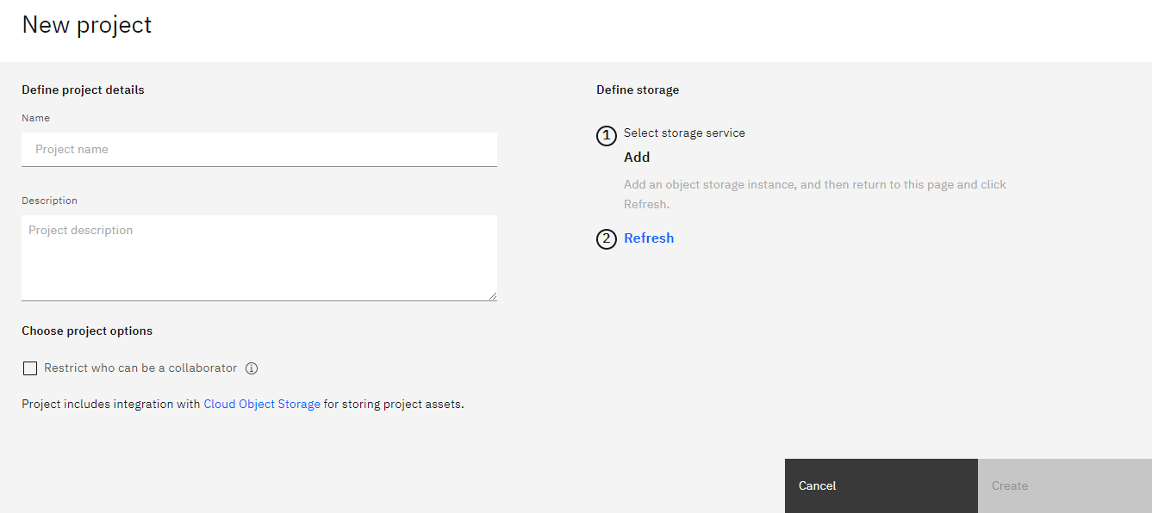

After creating the project continue with Step 4.

Step 4: Adding a Notebook to the Project:

You need to add a Notebook to your project. Click **Add to project**.

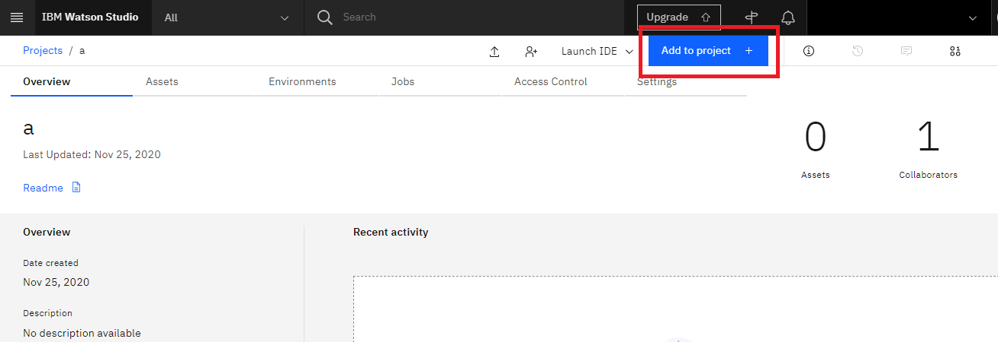

In the list of asset types, click **Notebook**.

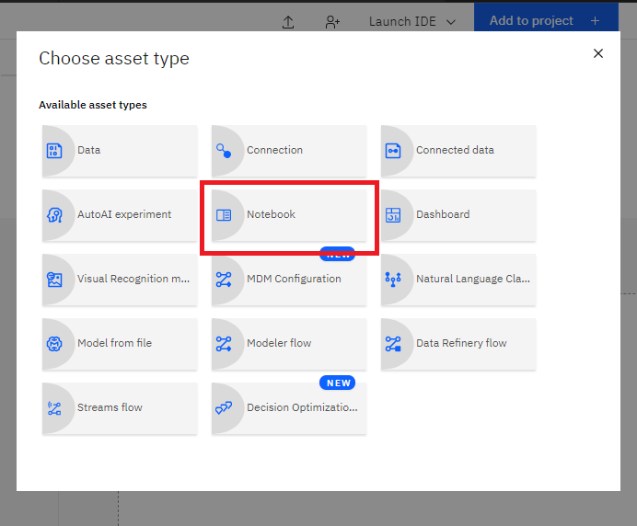

On the New Notebook page, enter a name for the notebook, and then click **From URL**.

Copy this [link](https://cf-courses-data.s3.us.cloud-object-storage.appdomain.cloud/IBMDeveloperSkillsNetwork-PY0101EN-SkillsNetwork/labs/FinalModule_edX/test_notebook.ipynb)

Paste it into the **Notebook URL** box, and then click **Create**.

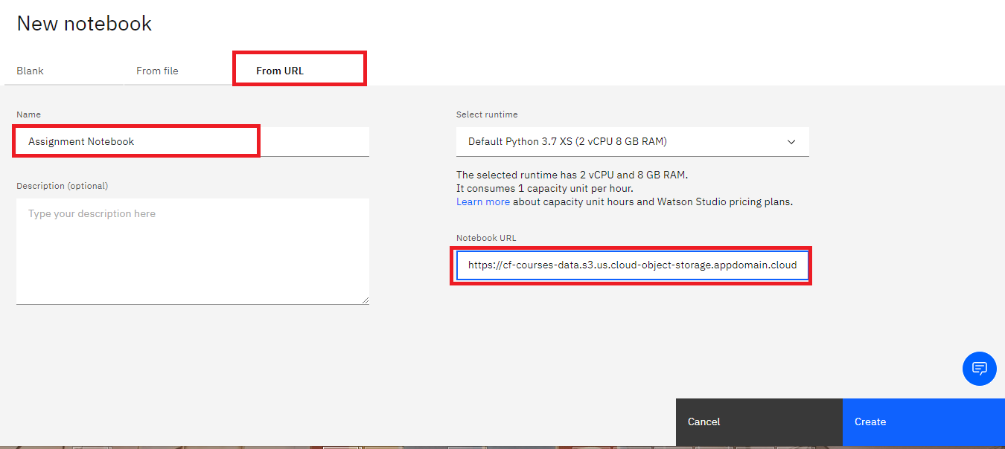

You will see this Notebook:



Once you complete your notebook you will have to save and share it to be marked.

To save the notebook, click on the save icon on the top left.

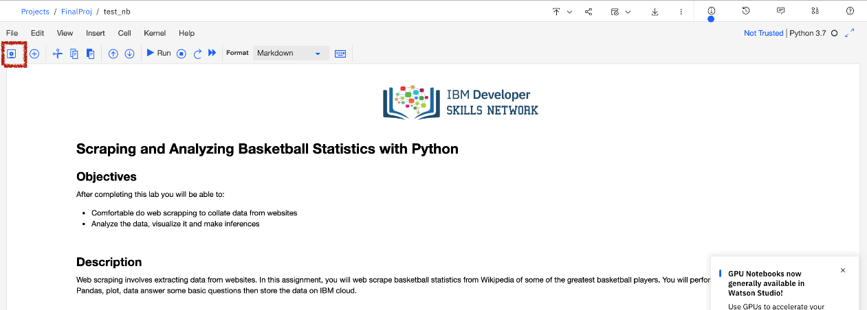

Select the icon on the top right a marked in red in the image below, a dialogue box should open, enable the option marked in red in the image below.

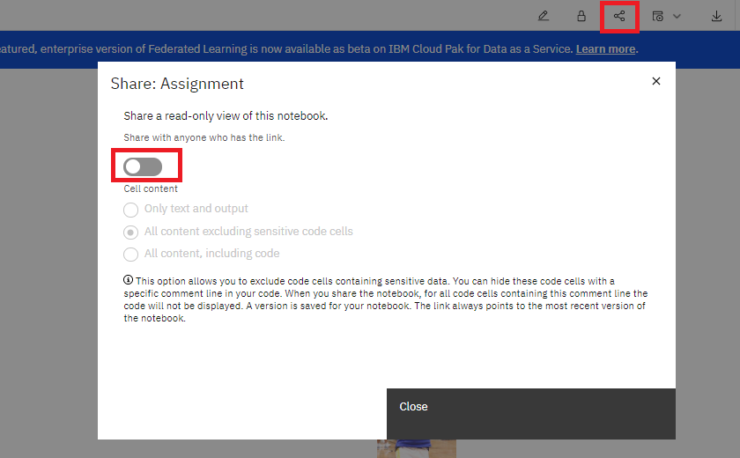

Once the option is enabled select the option all content excluding sensitive code cells and you can then share the notebook by copying the URL in the **Permanent link to view notebook**, as shown in the following image:

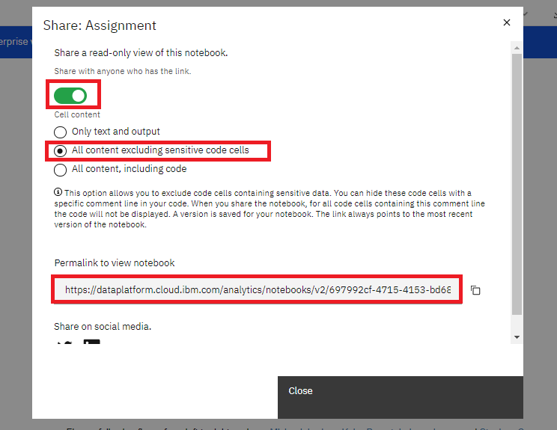

Paste the URL in a new browser window and check if the notebook is rendered as intended before sharing it for review with your peers.

Author(s)

[Joseph Santarcangelo](https://www.linkedin.com/in/joseph-s-50398b136/)